

[Date]

Date of Submission: 10.11.2020

Submitted to:

Name: Nourin Khandaker

Lecturer,

Dept. of CSE

at Bangladesh University of Business and Technology.

Submitted by:

Name: Syeda Nowshin Ibnat

ID: 17183103020

Intake: 39

Section: 01

Program:B.Sc. in CSE

Semester: Summer 2020

Lab Assignment

Course Code: CSE 316

Course Title: Microprocessor and Microcontroller Lab

**Task**

Create an arduino circuit with PIR sensor and LCD which will do the following things:

i) If the object is in range it will display on LCD "Object Detected"

ii) If not then it will display "Detecting.."

**Result**

**Code:**

#include <LiquidCrystal.h>

LiquidCrystal lcd(12,11,7,6,5,4);

void setup() {

Serial.begin(9600);

lcd.begin(16,2);

pinMode(8,INPUT); }

void loop() {

int a = digitalRead(8);

Serial.println(a);

if(a==1) {

lcd.setCursor(2,0);

lcd.print("Obj Detected");

delay(1000);

lcd.clear(); }

else {

lcd.print("Detecting.."); } }

**Image of the diagram:**

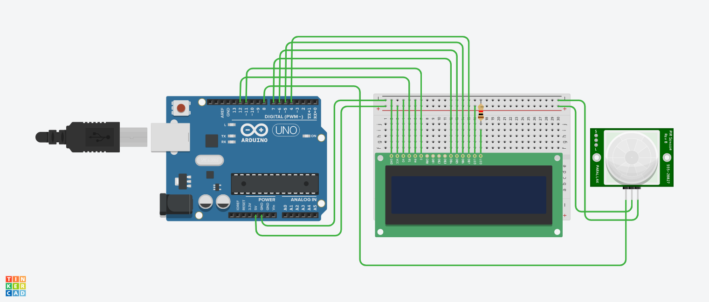

**Project Link:**

https://www.tinkercad.com/things/40N8da2mrLg-copy-of-pir-sensor-with-lcd-display/editel?sharecode=u_XRR5fZkl7Zs6hAoaVyzuIlO8MkEB1veFzZ0LMA0PU